TAITA TAVETA NATIONAL POLYTECHNIC

DEPARTMENT OF ELECTRICAL AND ELECTRONICS ENGINEERING
MECHATRONIC TECHNICIAN

SMART HOSPITAL QUEUE MANAGEMENT SYSTEM WITH TRIAGE AND SMS NOTIFICATION

Prepared by: Humphrey Kombe Nzai
Reg No:19596

This project is submitted in partial fulfilment of requirement for the Taita Taveta National Polytechnic award of DIPLOMA OF MECHATRONIC TECHNICIAN

DECLARATION
I hereby declare that this project report is based on my original work except for citations and quotations which have been duly acknowledged. I also declare that it has not been previously and concurrently submitted for any other degree or award
Signature:_______________
Name: Humphrey Kombe Nzai
ID No:42727481
Date:________________

SUPERVISOR
I the undersigned do hereby certify that this is a true report for the project undertaken by the above named trainee under my supervision and that it has been submitted to Taita Taveta National Polytechnic with my approval
Signature:________________
Date:________________

DEDICATION
Specially dedicated to
My beloved Mom and Dad, my Uncles and Aunts and to my Siblings

ACKNOWLEDGEMENT
I would like to express my sincere gratitude to my supervisor Stephanie Masika for the continuous support, guidance, and encouragement throughout the development of this project. I also acknowledge Taita Taveta National Polytechnic for providing the learning environment and technical knowledge necessary for the completion of this project. Finally, I appreciate my colleagues and family members who offered support and motivation during the research and development process.

ABSTRACT
The increasing patient congestion in hospital outpatient departments has created the need for automated queue management systems that can efficiently control patient flow, prioritize emergency cases, and provide real-time communication to patients. This project presents the design and implementation of a Smart Hospital Queue Management System with triage selection and SMS notification capabilities.
The system is developed using microcontroller-based embedded technology to automate token issuance, symptom-based patient classification, and queue monitoring. Patients interact with the system through a keypad interface where they select their symptom category. The system then generates a queue token, assigns the patient to the appropriate service room, and sends an SMS notification when the patient is two positions away from being served.
The prototype integrates an LCD display, keypad input, buzzer alert system, and GSM communication module to demonstrate real-time queue control. Experimental testing indicates that the system improves service efficiency and reduces waiting time in outpatient departments.

TABLE OF CONTENTS
Contents
DECLARATION 2
DEDICATION 3
ACKNOWLEDGEMENT 4
ABSTRACT 5
TABLE OF CONTENTS 6
CHAPTER ONE: INTRODUCTION 9
1.1 Background of the Study 9
1.2 Problem Statement 9
1.3 Research Objectives 9
1.4 Research Questions 9
1.5 Significance of the Study 10
1.6 Scope of the Study 10
1.7 Limitations of the Study 10
CHAPTER TWO: LITERATURE REVIEW 11
2.1 Introduction to Literature Review 11
2.2 Concept of Queue Management Systems 11
2.3 Embedded Systems in Healthcare Applications 12
2.4 Triage Systems in Healthcare 12
2.5 SMS Communication in Healthcare Systems 12
2.6 Review of Related Studies 12
2.7 Research Gap 12
CHAPTER THREE:METHODOLOGY 13
3.1 Introduction 13
3.2 Research Design 14
3.3 System Architecture 14
3.4 System Block Diagram 15
3.5 Hardware Components 15
3.5.1 Arduino Uno Microcontroller 15
3.5.2 Matrix Keypad 16
3.5.3 LCD Display (16×2 I2C) 16
3.5.4 Buzzer 16
3.5.5 SIM800L GSM Module 16
3.5.6 Power Supply Unit 17
3.6 Software Development 17
3.7 Triage Classification Algorithm 17
3.8 Data Collection 18
3.9 System Testing 18
3.9.1 Hardware Testing 19
3.9.2 Integration Testing 19
3.9.3 Performance Testing 19
3.10 Ethical Considerations 20
3.11 Chapter Summary 20
CHAPTER FOUR 20
SYSTEM DESIGN, IMPLEMENTATION AND RESULTS 20
4.1 Introduction 20
4.2 System Design Overview 20
4.3 Hardware Design 21
4.3.1 Hardware Components Used 21
4.4 Circuit Design 21
4.4.1 Keypad Connections 21
4.4.2 LCD I2C Connections 22
4.4.3 Buzzer Connection 22
4.4.4 GSM Module Connections 22
4.5 Software Design 23
4.6 Token Generation System 23
4.7 Triage Selection System 24
4.8 SMS Notification System 24
4.10 System Operation 25
4.11 System Testing Results 26
4.12 Challenges Encountered 26
4.13 System Advantages 27
4.14 Chapter Summary 27
CHAPTER FIVE: 28
CONCLUSION AND RECOMMENDATIONS 28
5.1 Introduction 28
5.2 Summary of the Study 28
5.3 Achievement of Project Objectives 29
Objective 1: Design a keypad-based token generation system 29
Objective 2: Implement a triage-based patient classification system 29
Objective 3: Display queue information on an LCD screen 29
Objective 4: Implement SMS notification using a GSM module 30
Objective 5: Provide audio alerts for queue notifications 30
5.4 Conclusion 30
5.5 Recommendations 30
5.6 Suggestions for Further Research 31
5.7 Final Remarks 31
REFERENCE 32
APPENDIX 1:Arduino Code 32

LIST OF FIGURES
FIGURE 2 LCD AND KEYPAD TESTING 18
FIGURE 3 TOKEN GENEREATION TESTING 18
FIGURE 4 GSM TESTING 19
FIGURE 5 SYSTEM OPERATION BLOCK DIAGRAM………………………………………………………………………………………………………………..25
FIGURE 6 HARDWARE CONNECTION…………………………………………………………………………………………………………………………………..22
FIGURE 7 FINAL DESIGN……………………………………………………………………………………………………………………………………………………..30

LIST OF TABLES
Table 1 SCOPE OF STUDY 10
Table 2 RESEARCH DESIGN 13
Table 3 TRIAGE CLASSIFICATION ALGORITHMS 17
Table 4 HARDWARE COMPONENTS USED 21

CHAPTER ONE: INTRODUCTION

1.1 Background of the Study
Healthcare service delivery is a critical component of modern society. Hospitals often experience overcrowding, especially in outpatient departments where patients arrive seeking consultation and treatment. Manual queue management methods are prone to human error, inefficiency, and long waiting times.
Traditional hospital queue systems rely heavily on reception staff to issue tokens and guide patients. However, such methods cannot guarantee fairness, prioritization of emergency cases, or real-time communication with patients.
Embedded systems and Internet-of-Things inspired technologies have been widely adopted to automate service processes in healthcare environments. Queue management systems help hospitals organize patient flow, reduce congestion, and improve overall service quality.
This project proposes the development of a Smart Hospital Queue Management System using microcontroller technology. The system combines triage-based classification, automated token generation, and SMS notification functionality.

1.2 Problem Statement
Hospitals in many developing regions face significant challenges in managing outpatient queues. Patients are often required to wait for long periods without receiving updates about their service status. Emergency patients may not receive priority attention in manual systems.
The absence of automated communication systems contributes to congestion and patient dissatisfaction. Therefore, there is a need to develop a low-cost embedded queue management solution suitable for resource-constrained healthcare facilities.

1.3 Research Objectives
General Objective
To design and implement a microcontroller-based smart hospital queue management system with triage selection and SMS notification.
Specific Objectives
- To design a keypad-based token booking interface.
- To implement symptom-based triage classification.
- To develop queue tracking and display logic using LCD.
- To integrate GSM communication for SMS notification.
- To evaluate system performance through prototype testing.

1.4 Research Questions
- How can patient queue management be automated using embedded system technology?
- How effective is triage-based classification in outpatient service delivery?
- What is the performance impact of SMS notification in queue management?

1.5 Significance of the Study
The project contributes to healthcare service improvement by demonstrating how low-cost embedded systems can be used to automate outpatient queue control. The system benefits patients by reducing waiting time and improving information accessibility.
The study is important to healthcare institutions, embedded system developers, and researchers exploring smart healthcare technologies.

1.6 Scope of the Study
The project focuses on outpatient queue management using prototype hardware consisting of:
Table 1 SCOPE OF STUDY
PROTOTYPE | FUNCTION
1.Microcontroller | Control unit
2.Keypad | Input interface
3.LCD | Display unit
4.buzzer | Alert system
5.GSM | SMS notification module

The system is not intended to replace full hospital management systems but to demonstrate embedded automation concepts.

1.7 Limitations of the Study
The project faced several limitations including:
- Dependence on GSM network availability
- Prototype-level implementation rather than full hospital deployment
- Power stability constraints during hardware testing

CHAPTER TWO: LITERATURE REVIEW

2.1 Introduction to Literature Review
Literature review provides theoretical and empirical foundation for the development of the Smart Hospital Queue Management System. Previous studies have explored the use of automation in healthcare service delivery, especially in patient flow control and communication systems, have explored the integration of digital token systems, electronic displays, and mobile notifications to manage patient flow.

2.2 Concept of Queue Management Systems
Queue management systems are designed to organize waiting lines and optimize service delivery. In healthcare environments, queue systems help reduce patient congestion and improve fairness in service allocation.
Several researchers have demonstrated that automated queue systems outperform manual reception-based queue control in terms of efficiency and reliability. Embedded electronic control systems have become popular due to their affordability and ease of implementation.
Platforms such as Arduino provide a convenient environment for developing prototype healthcare automation systems. Previous research has shown that Arduino-based systems can be effectively applied in monitoring devices, automated hospital equipment, and queue management applications.

2.3 Embedded Systems in Healthcare Applications
Embedded systems are computer-based control systems designed to perform dedicated functions. In healthcare technology, embedded systems are used in patient monitoring, appointment scheduling, and medical device automation.
Microcontroller platforms such as Arduino-based architectures have been widely adopted in academic prototype development due to their simplicity and open-source support.

2.4 Triage Systems in Healthcare
Triage is a medical prioritization method used to determine treatment order based on patient condition severity. Traditional triage is performed by trained medical personnel during emergency situations.
Automating triage selection in this project is achieved through keypad-based symptom category input. The system classifies patients into emergency, normal, or review categories. This approach is intended for prototype demonstration and not clinical diagnosis.

2.5 SMS Communication in Healthcare Systems
Short Message Service (SMS) technology provides a simple and reliable method of patient notification. SMS-based queue notification reduces patient crowding in hospital waiting areas.
The integration of GSM communication modules allows the system to send queue status alerts when the patient is approaching service position.

2.6 Review of Related Studies
Several studies have proposed automated hospital queue systems using microcontrollers and wireless communication technologies.
- Some researchers developed token issuance systems using keypad interfaces and display modules.
- Others implemented patient notification systems using GSM communication.
- Previous designs often lacked triage prioritization functionality.

2.7 Research Gap
Despite advances in healthcare automation, there remains limited integration of triage selection, queue monitoring, and SMS notification within a single embedded prototype suitable for low-resource hospital environments.
This project addresses the gap by designing a unified Smart Hospital Queue Management System combining these functionalities.

CHAPTER THREE:METHODOLOGY

3.1 Introduction
This chapter describes the research methodology used in the design and development of the Smart Hospital Queue Management System with Triage and SMS Notification. The methodology outlines the research design, system architecture, hardware components, software development, data collection methods, and testing procedures used to implement the system.
The main objective of the methodology is to provide a clear explanation of how the system was designed, developed, implemented, and evaluated to ensure that it meets the intended purpose of improving hospital queue management.

3.2 Research Design
The research adopted an experimental and system development design approach. This approach was suitable because the project involved designing and building a working prototype that demonstrates how automation can improve hospital queue management.
The research design followed several stages which included:
Table 2 RESEARCH DESIGN
- Problem identification – Understanding the challenges associated with manual queue systems in hospitals.
- System design – Designing the architecture of the proposed smart queue management system.
- Hardware implementation – Integrating electronic components such as the Arduino microcontroller, keypad, LCD display, buzzer, and GSM module.
- Software development – Writing and testing Arduino programs to control the system operations.
- System testing and evaluation – Testing the system functionality to ensure proper performance.
- Data analysis and documentation – Evaluating system performance and documenting the results.
This structured approach ensured that the project was completed in a systematic and organized manner.

3.3 System Architecture
The Smart Hospital Queue Management System consists of both hardware and software components that work together to automate patient queue handling.
The system operates using the following workflow:
- A patient arrives at the hospital reception.
- The patient enters information through the keypad interface.
- The system evaluates the patient's condition through the triage selection process.
- A token number is generated automatically.
- The token number is displayed on the LCD screen.
- The patient receives an SMS notification indicating their queue number.
- The system alerts patients when they are two people away from their turn.
- A buzzer alert and LCD display notify the patient when it is their turn.
- The system indicates the room number where the patient should go.
This architecture ensures efficient management of patient flow and reduces overcrowding in waiting areas.

3.4 System Block Diagram
The system is composed of several interconnected modules which work together to achieve the queue management functionality.
Main system components include:
- Input Module (Keypad)
- Processing Unit (Arduino Microcontroller)
- Display Module (I2C LCD)
- Alert System (Buzzer)
- Communication Module (SIM800L GSM)
- Power Supply Unit

FIGURE 5 SYSTEM FLOW
System Flow
Patient Input → Arduino Processing → Token Generation → LCD Display → SMS Notification → Buzzer Alert → Room Direction
The microcontroller acts as the central control unit that processes inputs and controls all system outputs.

3.5 Hardware Components
The hardware components used in the project were selected based on;
- reliability,
- affordability, and
- ease of integration.

3.5.1 Arduino Uno Microcontroller
The Arduino Uno serves as the main controller of the system. It processes inputs from the keypad and controls the output devices such as the LCD display, buzzer, and GSM module.
Key features include:
- ATmega328P microcontroller
- 14 digital input/output pins
- 6 analog input pins
- USB interface for programming
- Operates at 5V
The Arduino was selected because it is easy to program and widely used in embedded systems development.

3.5.2 Matrix Keypad
A 3×4 matrix keypad was used as the input interface of the system. It allows patients to interact with the system and select their symptoms or request a token number.
Functions of the keypad include:
- Selecting triage options
- Booking tokens
- Navigating system options
Matrix keypads are efficient because they reduce the number of required input pins.

3.5.3 LCD Display (16×2 I2C)
The system uses a 16×2 LCD display with an I2C interface to display information to users.
The LCD shows:
- Token numbers
- Triage status
- Queue updates
- Room directions
The I2C interface reduces wiring complexity since it requires only two communication lines.

3.5.4 Buzzer
A buzzer is used as an audio alert system. It notifies patients when:
- They are close to their turn
- It is their turn to see the doctor
The buzzer improves accessibility for patients who may not be looking at the display.

3.5.5 SIM800L GSM Module
The SIM800L GSM module is responsible for sending SMS notifications to patients.
Functions include:
- Sending token confirmation messages
- Alerting patients when they are next in line
- Notifying patients of their consultation room
The GSM module communicates with the Arduino through serial communication using AT commands.

3.5.6 Power Supply Unit
The system requires a stable power supply for proper operation.
The following power sources were used:
- Arduino USB power supply
- Lithium battery for GSM module
- Capacitor for voltage stabilization
The capacitor helps prevent voltage drops that may occur during GSM transmission.

3.6 Software Development
The software for the system was developed using the Arduino Integrated Development Environment (Arduino IDE).
The programming language used was C++ for Arduino, which allows direct interaction with the microcontroller hardware.
The program includes the following functions:
- Keypad scanning
- Token generation
- Triage classification
- Queue management
- LCD display control
- Buzzer alert system
- SMS notification using GSM module
Libraries used in the program include:
- Keypad library
- LiquidCrystal_I2C library
- SoftwareSerial library
These libraries simplify communication with the hardware components.

3.7 Triage Classification Algorithm
The triage system allows patients to select their condition using keypad options.
The system classifies patients into three categories:
Table 3 TRIAGE CLASSIFICATION ALGORITHMS
CATEGORY FUNCTION
1. Emergency - Patients with severe symptoms are given priority and directed immediately to the emergency room.

2. Normal Consultation - Patients with regular medical conditions are placed in the normal queue.

3. Review Appointment - Patients visiting for follow-up consultations are assigned a separate queue.

The triage algorithm ensures that critical patients receive medical attention faster.

3.8 Data Collection
Data collection during the project focused on system performance and functionality.
The following data were recorded:
- Number of tokens generated
- Queue processing time
- SMS delivery success rate
- System response time
Testing was conducted using simulated patient inputs through the keypad.

3.9 System Testing
Several tests were conducted to evaluate the functionality of the system.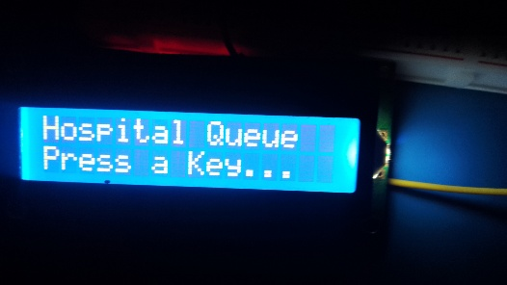
FIGURE 1 LCD AND KEYPAD TESTING
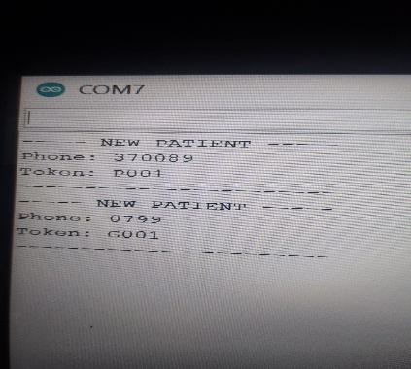
FIGURE 2 TOKEN GENEREATION TESTING
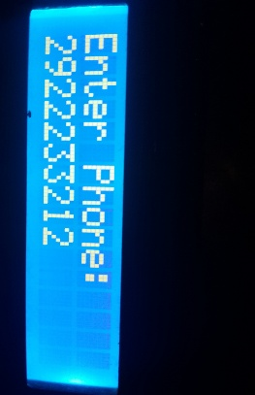
FIGURE 3 GSM TESTING

3.9.1 Hardware Testing
Each hardware component was tested individually before full system integration.
Examples include:
- Testing keypad input
- Testing LCD display messages
- Testing buzzer alerts
- Testing GSM SMS transmission

3.9.2 Integration Testing
Integration testing involved connecting all system components together and testing the overall system functionality.
The following operations were verified:
- Token generation
- Queue updates
- SMS notifications
- Alert system

3.9.3 Performance Testing
The system was evaluated based on:
- Speed of token generation
- SMS delivery time
- Accuracy of triage classification
- Reliability of hardware components
The system performed efficiently under simulated hospital conditions.

3.10 Ethical Considerations
The system does not store sensitive patient medical data. During testing, simulated data was used to ensure privacy and ethical compliance.
If implemented in real hospitals, the system would need to follow healthcare data protection policies.

3.11 Chapter Summary
This chapter presented the methodology used in designing and implementing the Smart Hospital Queue Management System. The chapter explained the research design, system architecture, hardware components, software development process, triage algorithm, and system testing procedures.
The next chapter presents the system design, implementation, and results of the developed system.

CHAPTER FOUR

SYSTEM DESIGN, IMPLEMENTATION AND RESULTS

4.1 Introduction
This chapter presents the detailed design, implementation, and operational results of the Smart Hospital Queue Management System with Triage and SMS Notification. The chapter explains how the system components were designed, connected, programmed, and tested to achieve the project objectives.
The system integrates hardware components and embedded software to automate hospital queue management. It allows patients to book tokens through a keypad, automatically classifies patients using a triage selection system, displays queue information on an LCD screen, alerts patients through a buzzer, and sends SMS notifications using a GSM module.

4.2 System Design Overview
The system was designed as a microcontroller-based embedded system consisting of input devices, a pro
cessing unit, output devices, and a communication module.
The system design focuses on the following key functions:
- Patient token booking
- Triage-based patient classification
- Queue monitoring and control
- Audio and visual alerts
- SMS notifications to patients
The Arduino Uno microcontroller acts as the central processing unit that coordinates communication between all modules.

4.3 Hardware Design
The hardware design involved connecting all electronic components in a way that allows them to communicate efficiently with the microcontroller.

4.3.1 Hardware Components Used
The following components were used in the development of the system:
Table 4 HARDWARE COMPONENTS USED
Component FUNCTION
Arduino Uno | System controller
3×4 Matrix Keypad | Patient input interface
Buzzer | Audio alert system
SIM800L GSM Module | SMS communication
Lithium Battery | GSM power supply
Capacitor | Stabilizes GSM voltage

Each component performs a specific role within the system.

4.4 Circuit Design
The circuit design involved connecting all hardware modules to the Arduino microcontroller.
Figure 6 HARDWARE CONNECTION
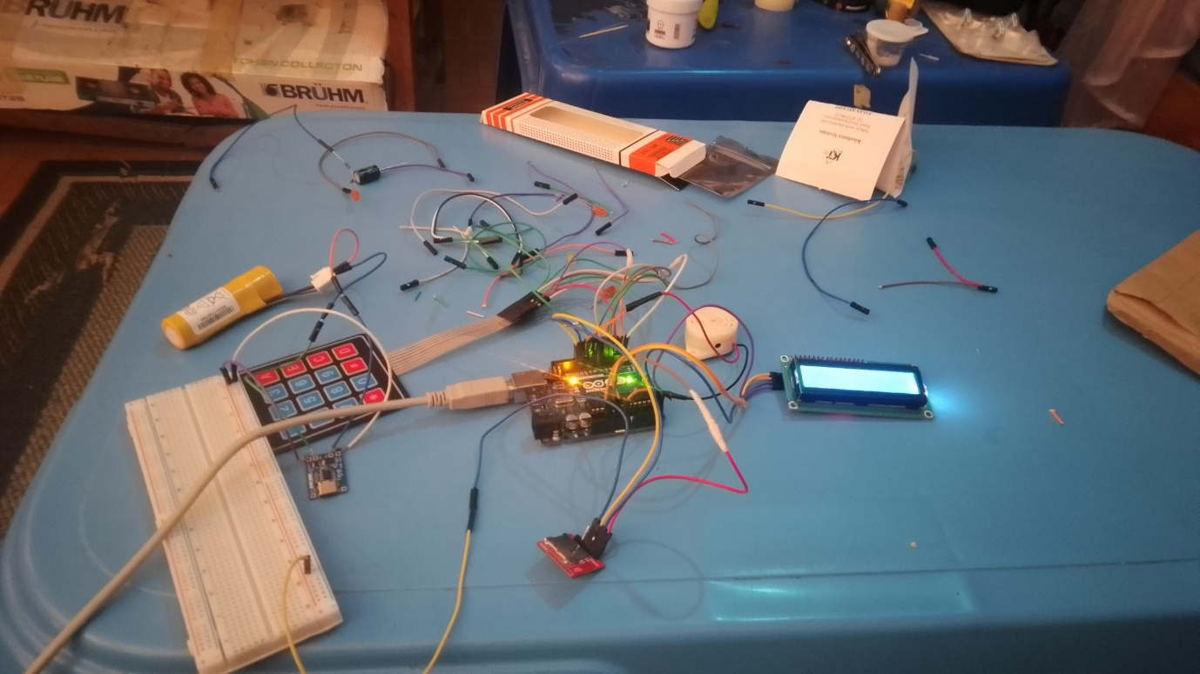

4.4.1 Keypad Connections
The 3×4 keypad consists of 4 rows and 3 columns.
Example connection:
Keypad Pin | Arduino Pin
Row1 | Pin 9
Row2 | Pin 8
Row3 | Pin 7
Row4 | Pin 6
Column1 | Pin 5
Column2 | Pin 4
Column3 | Pin 3
The keypad allows patients to interact with the system by selecting triage options.

4.4.2 LCD I2C Connections
The LCD display uses the I2C communication protocol, which requires only two data lines.
LCD Pin | Arduino Pin
VCC | 5V
GND | GND
SDA | A4
SCL | A5
The LCD is used to display:
- Token number
- Queue updates
- Patient instructions
- Room directions

4.4.3 Buzzer Connection
The buzzer is connected to a digital output pin of the Arduino.
Buzzer Pin | Arduino Pin
Positive | Pin 12
Negative | GND
The buzzer produces an audible sound when it is a patient's turn.

4.4.4 GSM Module Connections
The SIM800L GSM module communicates with Arduino through serial communication.
GSM Pin | Arduino Pin
VCC | Lithium Battery (3.7–4.2V)
GND | Arduino GND
TX | Arduino Pin 7
RX | Arduino Pin 8 (through voltage divider)
A 10kΩ resistor voltage divider was used to reduce the Arduino 5V signal to a safe level for the GSM RX pin.

4.5 Software Design
The system software was developed using Arduino IDE. The program was written in Arduino C++.
The program performs the following operations:
- Initializes system components
- Reads keypad input
- Generates patient tokens
- Classifies patients using triage logic
- Displays queue information on LCD
- Sends SMS notifications using GSM module
- Activates buzzer alerts
The program runs continuously in a loop to monitor patient input and update the queue.

4.6 Token Generation System
The token generation system assigns a unique number to each patient when they book a consultation.
The process works as follows:
- Patient presses the token booking key.
- The system increments the token counter.
- The token number is displayed on the LCD screen.
- The patient receives an SMS confirmation message.
Example:
Patient 1 → Token 001
Patient 2 → Token 002
Patient 3 → Token 003
This automated process eliminates manual queue management.

4.7 Triage Selection System
The triage system allows patients to select the type of medical service they require.
The keypad options were designed as follows:
Key | Function
1 | Emergency
2 | Normal Consultation
3 | Review Appointment
After selection, the system assigns the patient to the appropriate queue.
Example:
Emergency patient → Immediate priority
Normal patient → Standard queue
Review patient → Follow-up queue
This feature helps hospitals prioritize patients according to urgency.

4.8 SMS Notification System
The system uses the SIM800L GSM module to send SMS notifications to patients.
The SMS notifications include:
- Token confirmation
- Queue alerts
- Room direction
Example SMS:
"Your token number is 12. You are two patients away from your turn."
When the patient is next in line, the system sends another message:
"Token 12, please proceed to Room 3."
The GSM module uses AT commands to send the SMS messages.
Example commands used:
AT
AT+CMGF=1
AT+CMGS="+2547XXXXXXXX"
These commands enable the Arduino to communicate with the GSM network.
4.9 Buzzer Alert System
The buzzer provides audio alerts to ensure patients do not miss their turn.
The buzzer activates in two situations:
- When the patient is two people away
- When it is their turn
This ensures that patients remain attentive even if they are not watching the display.

4.10 System Operation
Figure 5 system operation block diagram
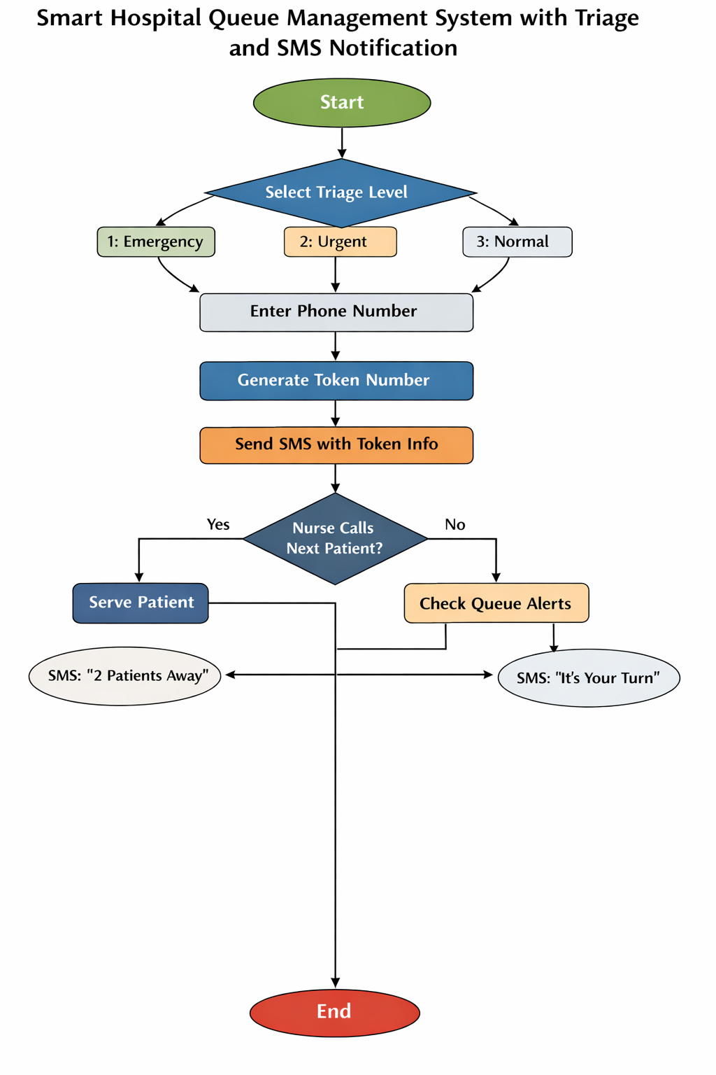
The full system operates according to the following sequence:
- The patient arrives at the reception.
- The patient selects their condition using the keypad.
- The system generates a token number.
- The LCD displays the token number.
- The GSM module sends an SMS confirmation.
- The queue advances as patients are served.
- When a patient is two people away, the system sends an alert.
- When it is their turn, the buzzer sounds and the LCD shows the room number.
This automated process improves efficiency in hospital waiting areas.

4.11 System Testing Results
The system was tested using simulated patient inputs.
The results were evaluated based on:
- Token generation accuracy
- Queue update speed
- SMS delivery
- Alert system functionality
Test Results
Test Item | Result
Keypad Input | Successful
Token Generation | Accurate
LCD Display | Working correctly
Buzzer Alert | Functional
GSM SMS Notification | Successful
Triage Classification | Correct
The system successfully performed all required functions.

4.12 Challenges Encountered
Several challenges were encountered during the project development.
GSM Communication Issues
During testing, the GSM module initially sent incorrect SMS characters due to communication errors between the Arduino and the GSM module.
This problem was addressed by:
- Adjusting the baud rate
- Stabilizing the power supply
- Adding capacitors
Keypad Hardware Issues
A faulty keypad caused some keys to fail during early testing. The issue was solved by replacing the keypad with a new unit.
Power Stability
The GSM module required a stable voltage supply. Voltage drops caused temporary communication failures.
Adding a capacitor and a dedicated lithium battery improved system stability.

4.13 System Advantages
The developed system provides several advantages:
- Reduces hospital congestion
- Improves patient experience
- Prioritizes emergency cases
- Automates queue management
- Provides real-time patient alerts
These benefits make the system suitable for hospitals with high patient traffic.

4.14 Chapter Summary
This chapter presented the design, implementation, and testing results of the Smart Hospital Queue Management System. The chapter explained how the hardware components were connected, how the software was developed, and how the system operates in a real hospital scenario.
The next chapter presents the conclusion and recommendations based on the results of the project.

CHAPTER FIVE:

CONCLUSION AND RECOMMENDATIONS

5.1 Introduction
This chapter presents the summary of the study, conclusions drawn from the project, and recommendations for future improvements of the Smart Hospital Queue Management System with Triage and SMS Notification. The chapter evaluates how the project objectives were achieved and discusses the potential impact of the system on hospital service delivery.
The project aimed to design and implement a low-cost automated queue management system that improves patient flow in hospitals by integrating token generation, triage classification, queue monitoring, and SMS notification technology.

5.2 Summary of the Study
Hospitals, particularly in developing countries, often face challenges related to long patient waiting times, disorganized queues, and inefficient communication between patients and healthcare providers. Traditional queue systems rely heavily on manual processes, which can lead to confusion, overcrowding, and patient dissatisfaction.
The purpose of this project was to develop a Smart Hospital Queue Management System that automates patient queue management using embedded system technology.
The project involved the design and implementation of a system consisting of several key components including:
- Arduino microcontroller
- 3×4 matrix keypad for patient input
- 16×2 I2C LCD display for queue information
- SIM800L GSM module for SMS notifications
- Buzzer for audio alerts
The system allows patients to book a queue token using a keypad, after which the system automatically assigns a token number and categorizes the patient based on a triage selection process.
The system then performs the following operations:
- Displays queue information on an LCD screen
- Notifies patients via SMS when they are two patients away from their turn
- Alerts the patient when it is their turn to see the doctor
- Directs the patient to the correct consultation room
The system was tested under simulated conditions to verify the functionality of all modules.
The results showed that the system was capable of:
- Generating patient tokens automatically
- Classifying patients using triage logic
- Displaying queue status correctly
- Sending SMS notifications to patients
- Providing audio alerts using a buzzer
The system therefore demonstrated its capability to improve queue management efficiency in hospital outpatient departments.

5.3 Achievement of Project Objectives
The objectives outlined at the beginning of the project were successfully achieved.
Figure 7 FINAL DESIGN
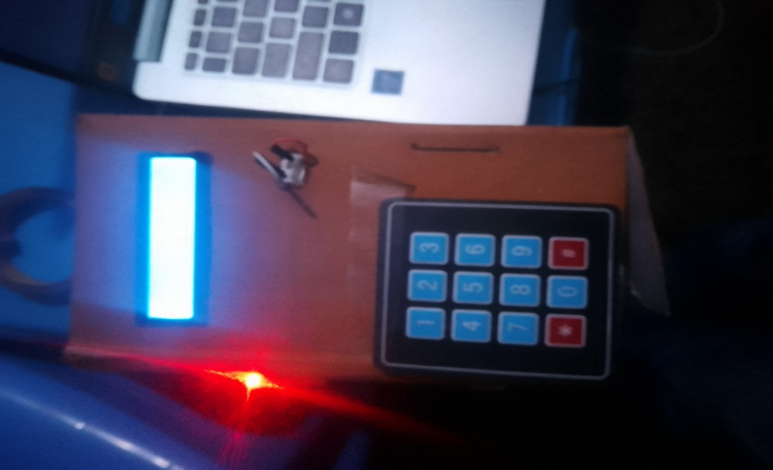

Objective 1: Design a keypad-based token generation system
This objective was achieved by developing a system that allows patients to interact with a 3×4 keypad to book their consultation token. The Arduino microcontroller processes the keypad input and automatically generates the next available token number.

Objective 2: Implement a triage-based patient classification system
The system includes a triage selection feature that allows patients to select their condition category using the keypad.
The categories include:
- Emergency
- Normal consultation
- Review appointment
This functionality allows hospitals to prioritize urgent medical cases.

Objective 3: Display queue information on an LCD screen
The 16×2 I2C LCD display successfully provides real-time information to patients including:
- Token number
- Queue status
- Instructions to proceed to the consultation room
This ensures that patients remain informed about their position in the queue.

Objective 4: Implement SMS notification using a GSM module
The SIM800L GSM module was integrated into the system to send SMS notifications to patients.
The system sends alerts when:
- The patient successfully books a token
- The patient is two people away from their turn
- It is the patient’s turn to see the doctor
This functionality reduces overcrowding in hospital waiting areas.

Objective 5: Provide audio alerts for queue notifications
A buzzer alert system was successfully implemented to notify patients when their turn approaches.
The buzzer improves system accessibility by ensuring that patients who may not be watching the display can still receive alerts.

5.4 Conclusion
Based on the system design, implementation, and testing results, it can be concluded that the Smart Hospital Queue Management System with Triage and SMS Notification provides an effective solution for improving patient queue management in healthcare facilities.
The system successfully demonstrates how embedded systems and communication technologies can be used to automate hospital processes and enhance service delivery.
Key benefits of the system include:
- Reduction of patient waiting time
- Improved queue organization
- Prioritization of emergency cases
- Better communication with patients through SMS alerts
- Reduction of overcrowding in hospital waiting areas
The system is low-cost, scalable, and suitable for deployment in small and medium healthcare facilities, particularly in developing countries where advanced hospital management systems may not be affordable.
The successful development of this project demonstrates the practical application of mechatronic engineering principles in healthcare technology.

5.5 Recommendations
Although the system performed well during testing, several improvements can be made to enhance its functionality and real-world applicability.
Integration with Hospital Database
Future versions of the system can integrate with a hospital electronic medical record (EMR) database to automatically store patient information and consultation records.
Mobile Application Integration
A mobile application can be developed to allow patients to:
- Book appointments remotely
- Check queue status
- Receive notifications through the app
This would further reduce hospital congestion.
Touch Screen Interface
Replacing the keypad with a touch screen interface could improve user interaction and provide a more modern system design.
Multiple Department Support
The system can be expanded to support multiple hospital departments such as:
- Laboratory services
- Pharmacy queues
- Radiology departments
This would transform the system into a full hospital queue management platform.
Cloud-Based Monitoring
Future versions of the system can upload queue data to a cloud server, allowing hospital administrators to monitor patient flow remotely.

5.6 Suggestions for Further Research
Further research can be conducted in the following areas:
- Artificial intelligence–based triage classification
- IoT-based hospital management systems
- Integration of biometric patient identification
- Real-time analytics for hospital patient flow management
These advancements would significantly improve the efficiency and intelligence of hospital service delivery systems.

5.7 Final Remarks
The Smart Hospital Queue Management System developed in this project demonstrates the potential of embedded systems technology to address real-world healthcare challenges.
By combining microcontroller automation, triage logic, GSM communication, and real-time patient alerts, the system offers an innovative approach to improving hospital service efficiency.
This project therefore contributes to the growing field of smart healthcare systems and digital hospital management technologies.

REFERENCE
Alhassan, A.R. & Asante, A.F. (2020). Improving healthcare service delivery through queue management systems.
Choudhary, D. & Shah, K. (2021). Smart hospital queue management using IoT and embedded systems.
Arduino Documentation (2024). Arduino Uno Technical Reference.

APPENDIX 1:Arduino Code

#include <Wire.h>
#include <LiquidCrystal_I2C.h>
#include <Keypad.h>
#include <SoftwareSerial.h>

LiquidCrystal_I2C lcd(0x27,16,2);
SoftwareSerial gsm(7,8);

int buzzer = 9;

// Queue arrays
int emergencyQueue[20];
int normalQueue[20];
int reviewQueue[20];

String phoneNumbers[60];

int eFront=0,eRear=0;
int nFront=0,nRear=0;
int rFront=0,rRear=0;

int token=1;
int servingToken=0;

String phone="";
int triageType=0;

// Keypad
const byte ROWS=4;
const byte COLS=3;

char keys[ROWS][COLS]={
{'1','2','3'},
{'4','5','6'},
{'7','8','9'},
{'*','0','#'}
};

byte rowPins[ROWS]={5,4,3,2};
byte colPins[COLS]={A2,A1,A0};

Keypad keypad=Keypad(makeKeymap(keys),rowPins,colPins,ROWS,COLS);

void setup()
{

Serial.begin(9600);
gsm.begin(9600);

pinMode(buzzer,OUTPUT);

lcd.init();
lcd.backlight();

lcd.print("MEDIQUEUE");
lcd.setCursor(0,1);
lcd.print("Starting...");

delay(3000);

showTriage();

Serial.println("==== MEDIQUEUE SYSTEM READY ====");
Serial.println("Press 'n' in Serial Monitor to call next patient");

}

void loop()
{

char key = keypad.getKey();

if(key)
{

// TRIAGE SELECTION
if(triageType==0)
{

if(key=='1'||key=='2'||key=='3')
{
triageType=key-'0';

lcd.clear();
lcd.print("Enter Phone:");
lcd.setCursor(0,1);
}

}

// PHONE ENTRY
else
{

if(key=='#')
{
registerPatient();
}

else if(key=='*')
{
phone="";
lcd.setCursor(0,1);
lcd.print(" ");
}

else
{
phone+=key;
lcd.setCursor(0,1);
lcd.print(phone);
}

}

}

// NURSE CALLS NEXT PATIENT
if(Serial.available())
{

char cmd=Serial.read();

if(cmd=='n')
{

serveNext();

}

}

}

// SHOW TRIAGE MENU
void showTriage()
{

lcd.clear();

lcd.print("1:Emerg 2:Norm");

lcd.setCursor(0,1);

lcd.print("3:Review");

}

// REGISTER PATIENT
void registerPatient()
{

phoneNumbers[token]=phone;

if(triageType==1)
{
emergencyQueue[eRear++]=token;
}

else if(triageType==2)
{
normalQueue[nRear++]=token;
}

else if(triageType==3)
{
reviewQueue[rRear++]=token;
}

Serial.print("Token ");
Serial.print(token);
Serial.print(" Registered | Phone:");
Serial.print(phone);
Serial.print(" | Triage:");
Serial.println(triageType);

lcd.clear();
lcd.print("Token:");
lcd.print(token);

tone(buzzer,1000,200);

// SEND TOKEN SMS
sendTokenSMS(phone,token);

token++;

phone="";
triageType=0;

delay(3000);

showTriage();

}

// SERVE NEXT PATIENT
void serveNext()
{

int currentToken=0;

if(eFront<eRear)
{
currentToken=emergencyQueue[eFront++];
}

else if(nFront<nRear)
{
currentToken=normalQueue[nFront++];
}

else if(rFront<rRear)
{
currentToken=reviewQueue[rFront++];
}

else
{

lcd.clear();
lcd.print("No Patients");

Serial.println("Queue Empty");

delay(2000);
showTriage();

return;

}

servingToken=currentToken;

Serial.print("Serving Token: ");
Serial.println(currentToken);

lcd.clear();
lcd.print("Serving:");
lcd.print(currentToken);

tone(buzzer,1500,500);

// SEND TURN SMS
sendTurnSMS(phoneNumbers[currentToken],currentToken);

// ALERT NEXT PATIENT
checkTwoAway();

}

// ALERT TWO PATIENTS BEFORE
void checkTwoAway()
{

int nextToken=0;

if(eFront<eRear)
{
nextToken=emergencyQueue[eFront];
}

else if(nFront<nRear)
{
nextToken=normalQueue[nFront];
}

else if(rFront<rRear)
{
nextToken=reviewQueue[rFront];
}

if(nextToken!=0)
{

Serial.print("Alert Token ");
Serial.println(nextToken);

sendAlertSMS(phoneNumbers[nextToken],nextToken);

}

}

// SEND TOKEN SMS
void sendTokenSMS(String number,int tokenNo)
{

gsm.println("AT");
delay(1000);

gsm.println("AT+CMGF=1");
delay(1000);

gsm.print("AT+CMGS=\"");
gsm.print(number);
gsm.println("\"");

delay(1000);

gsm.print("Hospital Token: ");
gsm.print(tokenNo);
gsm.println(". Please wait for your turn.");

delay(500);

gsm.write(26);

delay(5000);

}

// ALERT SMS
void sendAlertSMS(String number,int tokenNo)
{

gsm.println("AT");
delay(1000);

gsm.println("AT+CMGF=1");
delay(1000);

gsm.print("AT+CMGS=\"");
gsm.print(number);
gsm.println("\"");

delay(1000);

gsm.print("Token ");
gsm.print(tokenNo);
gsm.println(": You are next. Please get ready.");

delay(500);

gsm.write(26);

delay(5000);

}

// TURN SMS
void sendTurnSMS(String number,int tokenNo)
{

gsm.println("AT");
delay(1000);

gsm.println("AT+CMGF=1");
delay(1000);

gsm.print("AT+CMGS=\"");
gsm.print(number);
gsm.println("\"");

delay(1000);

gsm.print("Token ");
gsm.print(tokenNo);
gsm.println(": It is now your turn. Please proceed to the room.");

delay(500);

gsm.write(26);

delay(5000);

}

